You can assume the following values for all the questions unless otherwise mentioned differently:

|  |  |  |
| --- | --- | --- |
| VDD | µCOXW/L | VT |
| 10 V | 2 mA/V2 | 1 V |

1. Find out the value of R1 and R2 in the following circuit such that such that the gain of the amplifier is 2. (10)

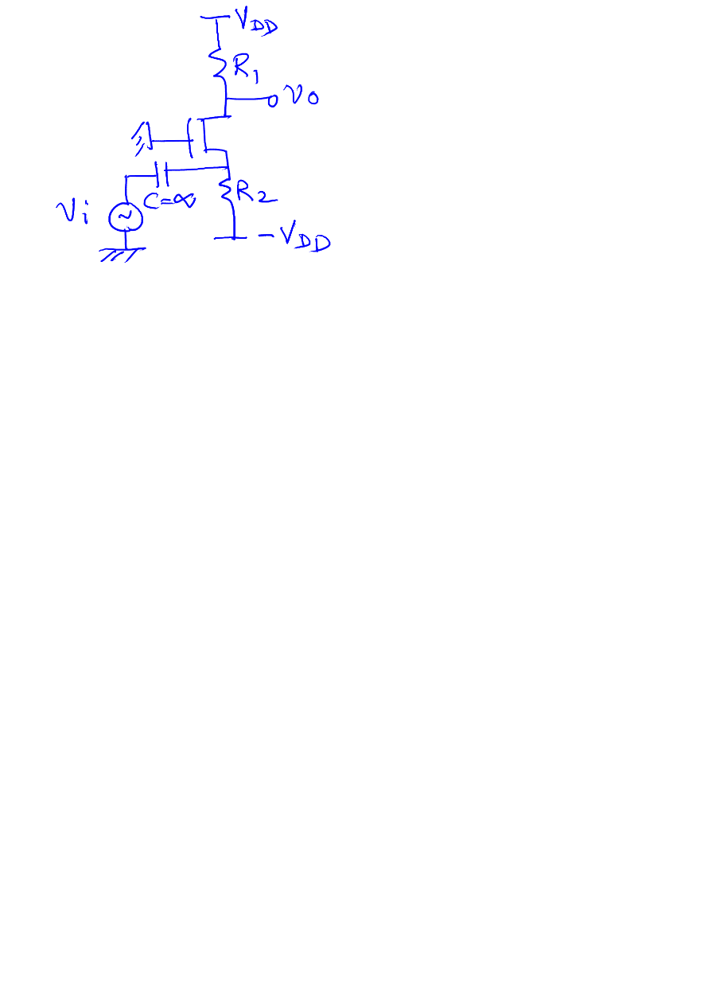

1. Plot output voltage as a function of input voltage for the following voltage sweep: VIN = +15 V → 0 V → -15 V → 0 → +15 V. Assume the OPAMP to be ideal in nature. R1 = 1 kΩ and R2 = 2 kΩ. (10)

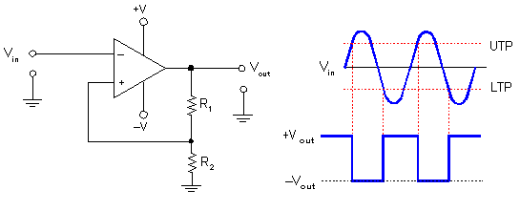

1. Find out the frequency of oscillation of the following circuit. Draw the waveforms at nodes a and b as a function of time clearly labeling the points of interest. (10)

|  |
| --- |
| http://www.play-hookey.com/analog/generators/images/square_triangle_gen.gif  b  a |

1. Find out the transfer function of the following circuit: (10)

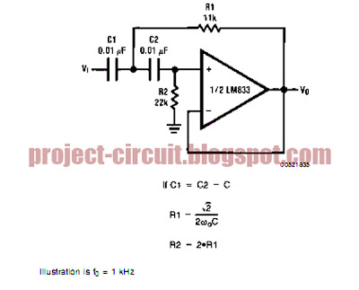

Draw Bode plots for magnitude and phase.

1. Find out the diode states using ideal diode model with proper justification. (10)

